
Project Proposal
Next Gen Architect (Auto floor plan Generation)
By:
Obaidullah 221109
Aashfa Noor 221017
Aliya Saqib 221015
Supervisor:
Dr Ashfaq Husain Farooqi
Air University Islamabad (AU) Department of Computer Science

Contents
1.Introduction 2
2.Related System Analysis 3
3. Problem Statement 3
4. Problem Solution / Objectives of the Proposed System: 4
5. Scope: 4
6. Modules 5
7. System Limitations/Constraints 7
8.Gathering Data Approach 7
9.Tools/Technologies: 7
10. Project Stakeholders 8
11. Module-based Work Division 8
12.Gantt Chart 9
13.Mockups 9
14.Conclusion 11
15. References 11

Supervisor Meeting Log:
 | Discussion | Task Assignment | Supervisor Signature
Meeting 01  Date: 18 - 02 – 2025 | FYP idea,  scope, Market Potential | Write Initial Proposal | 
Meeting 02  Date: 20- 02 – 2025 | Modules to include,  Stack selection. | Finalize The Modules | 
Meeting 03  Date: 25- 02 – 2025 | Scope Document | Finalization | 
Meeting 04  Date: 19- 03 – 2025 | Presentation | Prepare and Submit the Final Presentation | 
Meeting 05  Date: 20- 04 – 2025 | Scope Document | Revision in Document | 
Meeting 06  Date: 20- 05 – 2025 | Scope Document | Finalize Revision of Document | 

1.Introduction
The residential construction and planning sector faces significant challenges due to the time-consuming, costly, and expertise-dependent nature of traditional floor plan generation. Existing tools are often complex, paid, and inaccessible to non-experts, requiring weeks to complete designs and involving manual processes that lack user-friendly features. To address these issues, we propose NextGenArchitect, an AI-driven platform that automates floor plan generation and provides real-time 3D visualization. This innovative tool allows users to create compliant and customized floor plans in minutes, adhering to society-specific rules and regulations. With features like drag-and-drop customization, pre-approved templates, and an online approval system, NextGenArchitect eliminates the hassle of physical visits and empowers both architects and individuals to design efficiently. By reducing time, cost, and complexity, this platform aims to revolutionize residential construction planning, making it faster, more affordable, and accessible to all.

2.Related System Analysis
Application Name | Weakness | Proposed Project Solution
AutoCAD | Complex interface, requires expertise, time-consuming, and expensive. | NextGenArchitect simplifies complex design with an AI-powered platform, reducing expertise requirements, time, and costs for efficient, accessible solutions.
Revit | High learning curve, paid tool, and requires significant manual input. | NextGenArchitect providing a more user-friendly interface for 3D visualization, combined with AI-driven automation, to reduce complexity, costs, and manual effort.
Zameen.com | The current system emphasizes property listings but falls short in incorporating compliance with rules and regulations and lacks an integrated online approval system from relevant authorities or societies. | NextGenArchitect addresses these gaps by offering a comprehensive platform that integrates compliance rules and regulations, enabling users to seamlessly obtain online approvals for floor plans from relevant authorities or societies, streamlining the property approval process.
SketchUp | SketchUp has limited automation capabilities, requiring users to manually create and adjust 3D models, which can be time-consuming and demands a certain level of expertise | NextGenArchitect revolutionizes 3D modeling by offering advanced automation that seamlessly converts 2D designs into 3D models, eliminating the need for manual labor and reducing the time and expertise required.

3. Problem Statement
Designing floor plans for homes is currently a slow, expensive, and complicated process. The tools available are time-consuming, difficult for non-professionals to use, and require a lot of manual work because they lack AI integration. This makes it hard for regular people to create their own designs without hiring experts. Additionally, when people buy plots in housing societies, they must follow strict society guidelines for their floor plans. To understand these rules, they often have to make multiple physical visits, which is inconvenient and time-consuming. There is no platform that allows users to design and get their floor plans approved online from the comfort of their homes.

4. Problem Solution / Objectives of the Proposed System:
To address the challenges in residential floor plan design, we propose NextGenArchitect, an AI-driven platform that simplifies the creation of customizable floor plans. This platform will revolutionize the residential construction sector by reducing the time, cost, and complexity of designing floor plans. By integrating AI, real-time 3D visualization, and user-friendly features, NextGenArchitect will empower both professionals and non-experts to create designs quickly and efficiently. The platform will also eliminate the need for physical visits by providing an online system for designing and approving floor plans according to society-specific rules. With features like drag-and-drop customization, pre-approved templates, and a user-friendly interface, NextGenArchitect aims to make floor plan design accessible, affordable, and hassle-free for everyone.
4.1. Objectives
- To develop an AI-powered platform that simplifies floor plan generation, making it fast, accurate, and easy to use for both professionals and non-experts.
- To reduce the time and cost of designing floor plans by providing real-time customization options and eliminating manual processes.
- To guide users in creating compliant designs by clearly displaying society-specific rules and guidelines within the platform, ensuring adherence without requiring physical visits.
- To provide a user-friendly interface with drag-and-drop functionality and pre-approved templates (Pre-Approved 2 floor plans for each 5marla ,7 Marla ,10 Marla and 1 Kanal plot ), making floor plan design accessible to non-technical users.
- To offer real-time 3D visualization so users can see their designs instantly, improving decision-making and design accuracy.
- To create an online approval system that allows users to submit, review, and approve floor plans digitally, saving time and effort.
- To empower homeowners and small builders by providing an affordable and efficient tool for designing floor plans.
- To enhance the overall residential construction experience by making floor plan design faster, more affordable, and accessible to a wider audience.

5. Scope:
The scope of NextGenArchitect is to develop an AI-driven platform that simplifies residential floor plan design (ground floor), enabling users to create customizable designs with real-time 3D visualization and drag-and-drop functionality for easy modifications. The platform will integrate society-specific guidelines, eliminating the need for physical visits, and will provide an online approval system for seamless submissions.We are targeting three types of societies: public, private, and government. The platform will incorporate society-specific compliance rules (e.g., Bahria Town, CDA, Gohar Town) to ensure that all floor plans adhere to the unique regulations of each society. Additionally, the platform will offer two pre-approved 2D templates for each 5 Marla, 7 Marla, 10 Marla, and 1 Kanal plot to eliminate the risk of non-compliance and provide users with a seamless design experience. AI-powered design suggestions will further enhance usability for homeowners, builders, and architects. By ensuring a secure and regulated environment, NextGenArchitect aims to make floor plan design faster, more affordable, and more accessible, revolutionizing residential construction planning.

6. Modules

6.1. Admin Panel
- Admins can
  - create, update, or remove user accounts.
  - approve or reject societies that apply to join the platform.
  - manage and moderate user reviews for societies.
- Admins have authority to remove societies from the platform based on negative reviews or policy violations.
- Admins can review and approve/reject advertisement submissions.

6.2. Floor Plan Generation
- Automatically generate floor plans based on user input e.g plot size, number of rooms, room connections.
- Generative AI model for smarter, more realistic floor plan suggestions.
- Generate 4–5 optimized floor plans according to user preferences.
- Provide a 3D view of the floor plans.
- Enable Interactive 3D Design Tour, allowing users to:
  - Virtually walk through their design.
  - Modify components such as wall color, floor type, window style, etc. (Optional feature).

6.3. Sub-Admin Panel (Societies)
- Sub-admins can upload and manage floor plan rules specific to their society.
- Add, update, view, or delete plot listings.
- Review and approve/reject floor plans submitted by users based on compliance with society-specific rules.
- Set advertisement duration and subscription options for society promotions.

6.4. User Management
- Users can:
  - Browse available plots.
  - Generate and customize floor plans.
  - Save, retrieve, and update their designs.
  - Manage personal profiles.
  - Submit their floor plans for society approval (if the plot lies within that society).

6.5. Plot Management
- Societies can:
  - Add, update, or delete plot listings.
- Users can:
  - Search and filter plots based on plot number and other attributes.
- Each plot will include detailed information (e.g., length, width, status).
- Plot availability (e.g., available/sold) is dynamically updated in the system.

6.6. Floor Plan Management
- System stores all user-generated and customized floor plans.
- Users can save, retrieve, and make changes to their floor plans as needed.

6.7. Compliance Management and Regulation
- Sub-admins can:
  - Add, view, update, and delete compliance rules for their society.
  - Approve or reject floor plans based on these compliance checks.
  - Notify users regarding approvals, rejections, or updates related to compliance.

6.8. Designing and Customization
- Users can use a drag-and-drop interface to:
  - Add or modify elements ( walls, doors, windows ).
  - Adjust room positions based on personal preferences.

6.9. Authorization and Security
- Role-based access control ensures that users only see and do what they are authorized to.
- Secure login systems for Admins, Sub-admins, and Users.
- Protection of user data and secure session management.

6.10. Statistics and Reports
- Display total available plots in each society.
- Track and display statistics for registered societies.
- Generate reports on registered users.
- Display analytics on advertisement engagement and floor plan submission trends.

6.11. Advertisement Management
- Societies can publish ads to gain visibility.
- Admins can approve or reject advertisements.
- Sub-admins can manage ad durations and subscribe to promotional packages.

7. System Limitations/Constraints
Automated Floor Plan Generation Limitations: The system may not always generate optimal floor plans that perfectly match user preferences. Adjustments may still be required by designers or users. The system will generate the floor plan for ground level.
Customization Restrictions: Users may not be able to modify floor plans provided by the society, as these designs must strictly adhere to predefined architectural rules and guidelines. Pre-approved 2D templates only contains 2 floor plans for each 5marla ,7 Marla ,10 Marla and 1 Kanal plot. This ensures compliance but limits flexibility for customization.
Technical Failures: Unexpected system outages, server crashes, or internet connectivity issues may disrupt plot customization requests or data retrieval.
Compliance and Regulation Limitations: The system handles quantitative compliance, such as the number of rooms allowed per plot size (e.g., 5 Marla, 10 Marla) and basic room connectivity rules (e.g., living room linked to bedrooms, kitchens near dining areas). However, it does not validate complex architectural standards or customized regulatory requirements beyond predefined templates, limiting design flexibility.

8.Gathering Data Approach
Collecting data for this project proved to be a time-consuming task due to its broad scope. We dedicated significant effort to understanding the requirements and operations of NextGenArchitect, employing a thorough data-gathering approach focused on user needs, architectural guidelines, and design preferences. Data was collected through user interactions, surveys, feedback, and extensive online research to identify pain points and expectations in floor plan design. Guidance from our supervisor, combined with insights gathered from internet resources, has been invaluable in addressing challenges and refining our approach, ensuring the platform effectively meets user needs.

9.Tools/Technologies:
Tool | Use Case
Figma | UI/UX Design
Python | Backend development
React.js | Frontend development
GitHub | Code collaboration & management
Unity | simulation development
SQL | Database

10. Project Stakeholders
Stakeholder | - Dr Ashfaq Husain Farooqi (Supervisor)  - Obaidullah  - Aashfa Noor  - Aliya Saqib

11. Module-based Work Division
Table: Team Member Work Division for Proposed Project
Student Name | Student Registration Number | Responsibility / Module / Feature
Member 1  (Aashfa Noor) | 221017 | Module 6.3 Sub Admin (societies) Panel  Module 6.7 Compliance Management and Regulation  Module 6.8 Designing and Customization  (Front end and Backend)  Module 6.2 Floor Plan Generation (Backend)
Member 2  (Aliya Saqib) | 221015 | Module 6.5 Plot Management  Module 6.4 User Management  (Front end and Backend)  Module 6.6 Floor Plan Management  Module 6.2 Floor Plan Generation(2D to 3D conversion )  Module 6.11 Advertisement Management
Member 3 (Obaidullah) | 221109 | Module 6.1 Admin Panel  Module 6.10 Statistics and Reports  (Front end and Backend )  Module 6.9 Authorization  Module 6.2 Floor Plan Generation  (Front End )

12.Gantt Chart
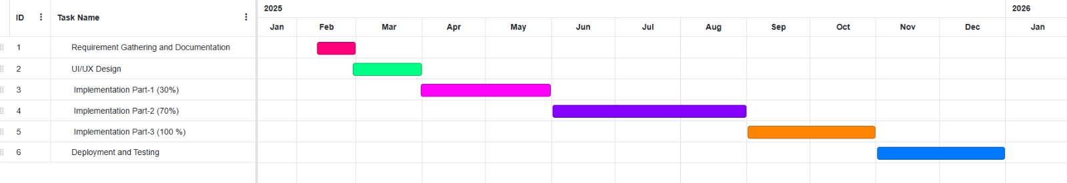

13.Mockups
Admin Dashboard:
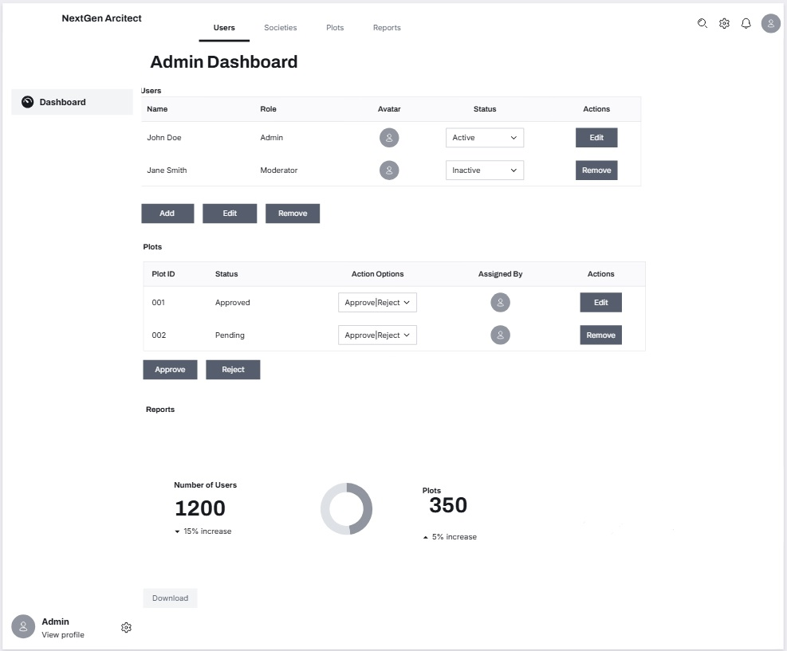 Description: This is the admin dashboard, where administrators can manage users, oversee plot approvals, and view real-time reports on system activities and user interactions.
Society Panel:

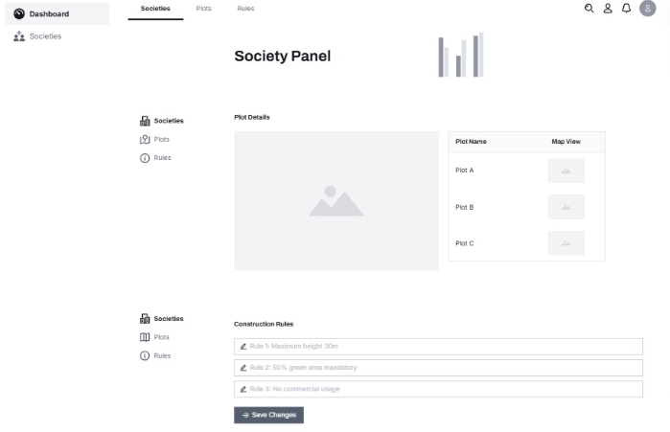 Description: This is where the society admin can handle plot information, construction rules, and make sure everything follows the required guidelines for proper planning and development.
Floor plan Generation:
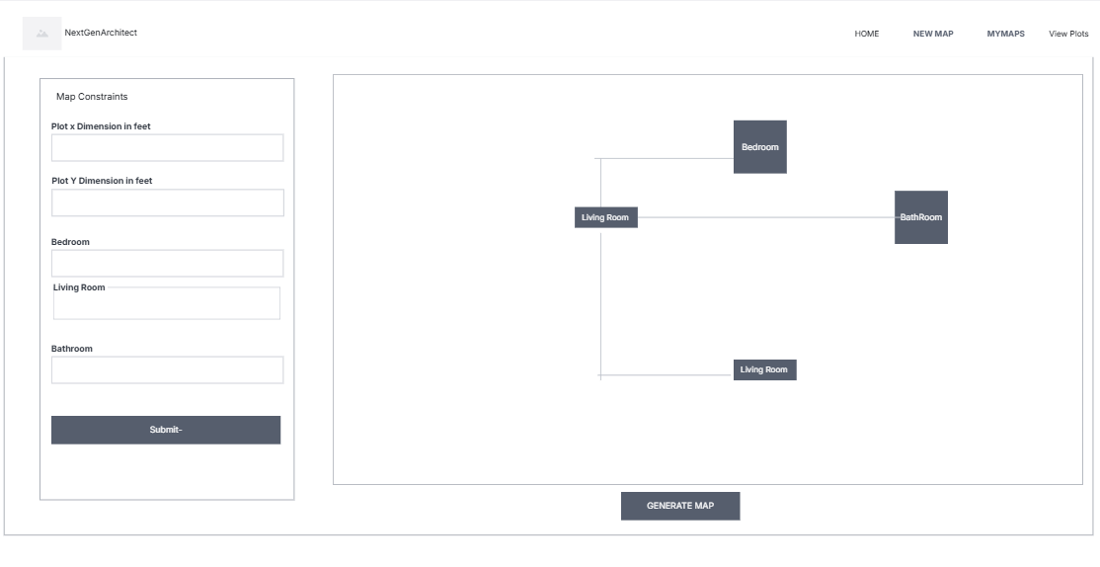 Description: This is where users can input plot dimensions, select room types, and generate customized floor plans using the NextGenArchitect platform.

14.Conclusion
NextGenArchitect revolutionizes residential floor plan design by offering an AI-driven, user-friendly platform that simplifies the creation of customizable floor plan. With real-time 3D visualization, and drag-and-drop functionality, it eliminates the need for physical visits and manual processes. By reducing time, and complexity, the platform empowers both professionals and non-experts, making floor plan design faster, more affordable, and accessible to all. This innovation paves the way for a more efficient and inclusive future in residential construction planning.

15. References
1. Michalewicz, Zbigniew. "Genetic Algorithms + Data Structures = Evolution Programs." Springer Science & Business Media, 1996. https://vdoc.pub/documents/genetic-algorithms-data-structures-evolution-programs-1s050de1hheg
2. Stacey, Martin. "Automatized Space Layout Planning from Preceding Typologies." Master’s Thesis, Bartlett School of Graduate Studies, University College London, 2017. https://www.academia.edu/34811901/Collective_Knowledge_is_the_Architect_Automatized_Space_Layout_Planning_from_Preceding_Typologies

